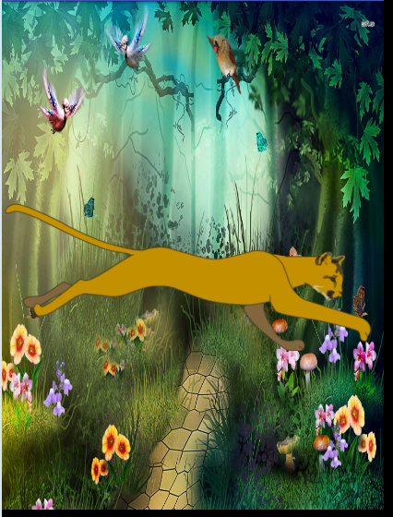

*<?***xml version="1.0" encoding="utf-8"***?>*<**animation-list xmlns:android="http://schemas.android.com/apk/res/android"**>  
<**item android:drawable="@drawable/runningcat_01" android:duration="100"**/>  
<**item android:drawable="@drawable/runningcat_02" android:duration="100"**/>  
<**item android:drawable="@drawable/runningcat_03" android:duration="100"**/>  
<**item android:drawable="@drawable/runningcat_04" android:duration="100"**/>  
</**animation-list**>

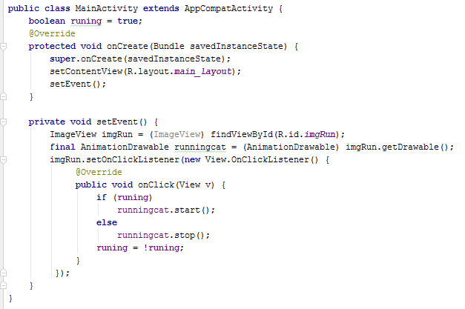



*<?***xml version="1.0" encoding="utf-8"***?>*<**set xmlns:android="http://schemas.android.com/apk/res/android"**>  
 <**scale  
 android:interpolator="@android:anim/bounce_interpolator"  
 android:fromXScale="0.0"  
 android:toXScale="1.0"  
 android:fromYScale="0.0"  
 android:toYScale="1.0"  
 android:pivotX="50%"  
 android:pivotY="50%"  
 android:fillAfter="true"  
 android:fillBefore="true"  
 android:duration="500"  
 android:repeatMode="restart"  
 android:repeatCount="infinite"** />  
</**set**>

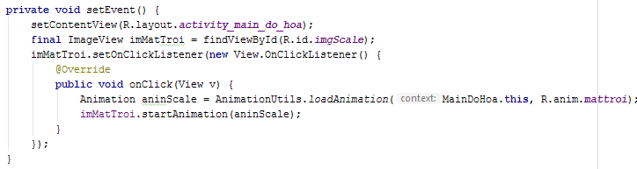

SplashScreenActivity

**public class** SplashScreenActivity **extends** AppCompatActivity {  
 @Override  
 **protected void** onCreate(Bundle savedInstanceState) {  
 **super**.onCreate(savedInstanceState);  
 setContentView(R.layout.***activity_main_splash***);  
 ImageView cat = (ImageView) findViewById(R.id.***imgCat***);  
 **final** AnimationDrawable runningCat = (AnimationDrawable) cat.getDrawable();  
 runningCat.start();  
 **final long** SPLASH_TIME_OUT = 3000;  
 **new** Handler().postDelayed(**new** Runnable() {  
 @Override  
 **public void** run() {  
 Intent i = **new** Intent(SplashScreenActivity.**this**, MainActivity.**class**);  
 startActivity(i);  
 finish();  
 }  
 }, SPLASH_TIME_OUT);  
 }  
}